1.Write a java program to create a class student with multiple constructor
class Student{
int id;
String name;
Student(){
id=0;
name="Unknown";
}
Student(int id,String name){
this.id=id;
this.name=name;
}
void display(){
System.out.println("Student Id: "+id);
System.out.println("Student Name: "+name);
}
}
class CollegeStudent extends Student {
CollegeStudent(int id,String name) {
super(id,name);
}
void display() {
System.out.println("College Student detail");
System.out.println("Id: "+id);
System.out.println("Name "+name);
}
}
public class Main {
public static void main(String[]args) {
Student s1=new Student();
Student s2=new Student(101,"Gayu");
CollegeStudent s3=new CollegeStudent(102,"sundar");
System.out.println("Default Constructor:");
s1.display();
System.out.println("\n Parameterized Constructor:");
s2.display();
System.out.println("\n Method Overriding:");
s3.display();
}
}
OUTPUT:

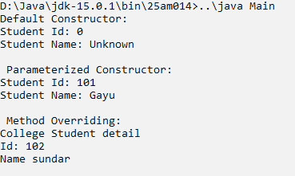

2.Write a java program to create a class employee that maintain a static variable to count the total number of employees created.
class Employee {
static int count = 0;
private double salary;
Employee(double salary) {
this.salary = salary;
count++;
}
public void setSalary(double salary) {
this.salary = salary;
}
public double getSalary() {
return salary;
}
public static void totalEmployees() {
System.out.println("Total Employees: " + count);
}
}
public class Employees {
public static void main(String[] args) {
Employee e1 = new Employee(30000);
Employee e2 = new Employee(40000);

System.out.println("Employee 1 Salary: " + e1.getSalary());
e1.setSalary(35000);
System.out.println("Updated Salary: " + e1.getSalary());
Employee.totalEmployees();
}
}
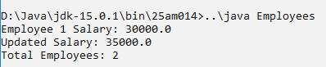
OUTPUT:

3.Develope a java class Book with parameterized and default constructor to demonstrate constructor overloading and extend it into a subclass EBook tht override a method to display Book details differently.
class Book {
String title;
String author;
Book(){
title="Unknown";
author="Unknown";
}
Book(String title,String author) {
this.title=title;
this.author=author;
}

void display() {
System.out.println("Book Title: "+title);
System.out.println("Author: "+author);
}
}
class Ebook extends Book {
Ebook(String title,String author) {
super(title,author);
}
void display() {
System.out.println("E-Book Details");
System.out.println("Title: "+title);
System.out.println("Author: "+author);
}
}
public class Sample {
public static void main(String[]args) {
Book b1=new Book();
Book b2=new Book("Java Programming:","James");
Ebook eb=new Ebook("Java Basics","Oracle");
System.out.println("Default Constructor:");
b1.display();
System.out.println("\n Parameterized Constructor:");
b2.display();
System.out.println("\n Overridden Method:");
eb.display();
}
}
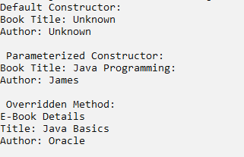
OUTPUT:

4.Construct a java program for a class product that uses a static variable to track the total number of products created.
class Product {
static int count = 0;
private double price;
Product(double price) {
this.price = price;
count++;
}
public void setPrice(double price) {
this.price = price;
}

public double getPrice() {
return price;
}
public static void totalProducts() {
System.out.println("Total Products: " + count);
}
}
public class Mains {
public static void main(String[] args) {
Product p1 = new Product(500);
Product p2 = new Product(800);
System.out.println("Product Price: " + p1.getPrice());
p1.setPrice(600);
System.out.println("Updated Price: " + p1.getPrice());
Product.totalProducts();
}
}
OUTPUT:
